# 

# **INTERNAL ASSESSMENT**

# BUSINESS MANAGEMENT

# To what extent is the merger of Vodafone and Idea a strategic move to defend their market share?

SESSION: May, 2020

WORD COUNT:

CITATION STYLE: MLA7

**INTRODUCTION**

Markets were moved by mergers and acquisitions. The stock market initially ignited with speculation. Soon came a big declaration. Days later, telecom goliaths –Idea and Vodafone – reported subtleties of the merger between the two organizations to make the greatest telecom organization in India.[1] So while the news excited the investors, details of the deal announced on March 20, 2017 led to a sharp fall in the share price of Idea Cellular. VIL is an Aditya Birla Group and Vodafone Group partnership. With over 408 million customers and a market share of revenue of 32.2 per cent (Q1FY19), it is India's largest telecom service provider[2]. In 2018, the global economy reported a healthy 3.6 per cent rise. Nevertheless, the global economy lost some momentum during the second half of the year, mostly due to the growing trade frictions between the US and China, and the tightening of financial conditions. In 2019, the International Monetary Fund (IMF) expects growth to decline to 3.3 per cent and the forecasts indicate that, in 2019, the world economy's three main engines, viz. the US, China and the Eurozone are predicted to decelerate. However, on the bright side, by 2020, the IMF expects global economic performance to rebound and rise at 3.6 per cent. The merger, Vodafone Idea Limited will likely face a difficult time defending its market share as it may be unable to make comparable capex infusions in augmenting 4G network capacity for fighting Bharti Airtel and Reliance Jio InfoComm due to its high leverage and sizeable combined debt levels[3]. While Vodafone Idea can find defending its market share tough, tools, such as SWOT analysis, perception map, and profitability analysis, could help the business assess and propose a solution to their situation.

I have based my analysis on the following:

* Interview with regional manager of Vodafone idea Limited.
* News article on the affects of Vodafone and Idea merger on its consumers.
* News article on Vodafone-Idea status on defending its market share.
* Financial ratios of VIL.
* News article on technologies used by VIL to defend its market share.

**ANALYSIS AND DISCUSSION:**

* **SWOT ANALYSIS**

SWOT analysis is a tool or a planning technique used to identify the strengths, weakness, opportunities, and threats of an organization. This analysis will help me understand the current and future status of Vodafone-Idea limited.

|  |  |
| --- | --- |
| **STRENGTH**   * Large customer base * Robust Network Infrastructure * Strong brand * Enterprise offerings * Tower investments | **WEAKNESS**   * Service quality issues * Net loss in market share. |
| **OPPURTUNITY**   * Advanced technology available. * Largest telecom company | **THREATS**   * Revenue leakage * Loss of revenue market share and customer base. * Merger might not survive. |

Considering the table above, we can see that VIL benefits from some opportunities, that is enabled by its strengths. Vodafone, which is ranked No.2, and Idea, which is ranked No.3, will be merging into the Indian Telecom market to become No.1, moving Bharti Airtel, ranked No.1, to No.2. Overall restructuring in the debt-ridden telecommunications industry would result in better financial health and market sustainability. Because restructuring leaves only three major corporations in the market, there will be less competition and greater revenues. As of December 31, 2018, Vodafone-Idea, India's largest mobile telecommunication subscription service, had over 387.2 million subscribers. VIL has great network assets in the form of 2G, 3G, 4G equipment and country wide optical fiber cable (OFC), having over 198,000 2G sites and over 376,000 broadband (3G+4G) sites[4]. The incremental capex coupled with the redeployment of the co-located broadband sites would allow the company to extend its broadband coverage and build large capacity. The two established brands, Vodafone and Idea, have largely contributed to a strong market position.[5] Idea with a focus on the mass market and an urban emphasis on Vodafone builds broad consumer loyalty across the world. These have led Vodafone Idea to opportunities in the telecom company and have benefited to their market share, such as the power of being the biggest telecom operator. Also, Vodafone Idea merger is a 50-50 partnership and therefore, this benefits them from accessing partner-only resources for training, marketing, sales, service, and technical support. It also benefits them from collaborating and networking with other partners in the IoT (Internet of Things) value chain. However, the flaws, issues in service quality and net loss in market share, have opened them to threats. Vodafone Idea might face revenue leakage, and is likely to report a net loss of over Rs 4,000 crore in the September quarter (Q2FY20) amid the ongoing battle of survival for the telecom player and consequently a significant customer exit on a QoQ basis. This loss of revenue market share is due to the loss in customer base.

* **POSITION (PERCEPTION) MAP**

It is one of the most useful and simplest tools to marketers. Position map allows a business to identify any gaps in its product portfolio. Information in a perception map can also help businesses to refine their marketing strategies.

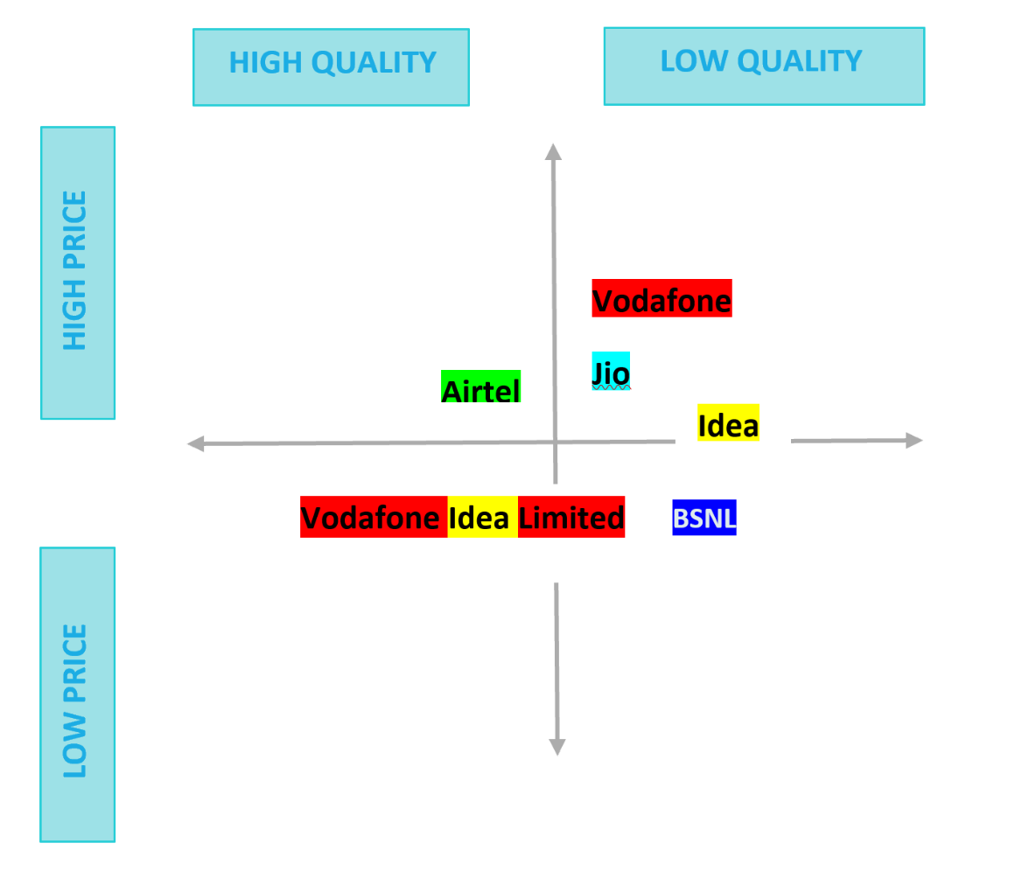

Vodafone and Idea were cowboy brands that provided lower quality services for higher prices. They didn’t have enough towers to satisfy customer’s network needs. While facing issues with the quality of service, the customers were paying high prices for voice and data services. 30% of those who use Vodafone have faced call connect failures and drops increase significantly in last 3 months. 15% of those who used Idea have faced call connect failures and drops increase significantly in last 3 months[6]. This resulted in their loss of customers and brand loyalty, which affected its market share. To defend this, they have merged to become Vodafone Idea Limited. Customers prefer to buy jio sim cards over the others, and face service issues. Airtel is comparatively better at providing services but costs higher than most of the telecom companies. Airtel and Jio have better schemes, however, Airtel has the best prepaid and postpaid plans[7]. Whereas, BSNL provides lower quality services and is the least expensive. Vodafone Idea Limited is a bargain brand[8] which provides better quality service for lower prices. With advancing in the number of towers, using both Idea’s and Vodafone’s towers, they have enabled themselves to provide stronger network services for their customers. Vodafone Group and Vodafone Idea Ltd through its subsidiary Aditya Birla Telecom Ltd. (ABTL), is one of the world’s leading tower company with 124,069 towers and a tenancy ratio of 1.86 as of December 31, 2018. Vodafone Idea owns 11.15% stake in Indus[9]. The proportionate profit/loss of Indus is presently consolidated at the PAT level in Vodafone Idea’s financial statements[10]. The brand together will provide customers new technology along with better network. VIL will have better digital services: Voice, Data, Mobile payments, IoT, advanced enterprise offerings, high speed and secure leased lines, digital wallets, MIMO and cloud services. Such services are accessible across 15,000 stores and 1.7 million retail touch points[11]. With a broad spectrum portfolio and a range of broadband carriers serving the increasing demand for data and speech, the company is committed to providing wonderful consumer experiences and contributing to the development of a truly 'Digital India' by enabling millions of people to connect and create a better tomorrow.

* **PROFITABILITY ANALYSIS**

*VIL financial ratios[12]*

|  |  |  |  |
| --- | --- | --- | --- |
|  | March 2019 | March 2018 | March 2017 |
| Gross Profit Margin (%) | -28.57 | -9.59 | 6.78 |
| Net Profit Margin (%) | -38.13 | -16.02 | -2.35 |
| ROCE | -5.49 | -2.35 | 3.43 |
| Gearing Ratios | 1.03 | 0.99 | 1.02 |

Currently, the company suffers low profitability. Vodafone Idea will find protecting its market share difficult. “The merged entity would be vulnerable to market share losses as both Jio and Bharti are ahead of Vodafone and Idea in data investment, and are likely to poach their customers”, said Bank of America-Merrill Lynch[13]. As the table above shows, the GPM (Gross Profit Margin) and NPM (Net Profit Margin) is decreasing from the year 2017 to 2019, and might continue to decrease. This is because they are losing their customer base as the customers are not satisfied with the company’s quality of service. This will decrease their revenues, therefore, less profit coming in the business. However, if VIL decreases their manufacturing and daily costs, they could reduce their expenses and gain higher profit. The decreasing ROCE also indicates that the company is not efficiently managing its finance. The company can improve its ROCE by removing unused or unnecessary assets, which allows for less capital to be employed to facilitate the same amount of production. Moreover, paying off debts and reducing liabilities can also improve the company’s ROCE ratio.[14]

To defend its market share, VIL will use high-end technology to extend 4G coverage. VIL will use a combo of advanced technologies, such as Dynamic Spectrum Refarming (DSR) to massive MIMO to achieve rapid expansion in its countrywide 4G coverage and data capacity to defend market share in its fight against Reliance Jio InfoComm and Bharti Airtel[15]. However, as the company is already facing financial issues, they won’t be able to adapt this technology instantly. They will have to use the solutions mentioned above to increase their profit margin at first and then use it to invest in the technology to advance from other competitors in the market.[16]

**CONCLUSION:**

This IA examined the RQ: “To what extent is the merger of Vodafone and Idea a strategic move to defend their market share?” Vodafone and Idea have merged aiming to be the greatest telecom company in India. For this, they have to compete against the top telecom companies, Bharti Airtel and Jio. As per the research, to achieve their desired goal and survive in the market, VIL has invested in network towers and enables advanced technology for themselves and their customers. Doing this, they have increased their costs and expenditures while keeping its selling prices low. Low price with good quality makes them a bargain brand.

Considering VIL’s profitability analysis, if they don’t reduce their costs/expenditures and continue selling their products at a low price, they will not be making any profits in future and will suffer major loses. Therefore, due to financial issues, they won’t be able to adapt advance technologies, like DSR to MIMO. They will have to increase their profit margin by using the strategies and solutions mentioned in the analysis.

It is recommended that VIL use its profitability analysis to understand its expenses and incomes, and accordingly reduce its expenses, such as investments in network towers, and improve its ROCE for better profit efficiency. (in terms of profitability and the right customer perception regarding the newly established brand). However, due to limited quantitative and qualitative data, there are several variables which could not be analyzed (find out what variables you could not include, 2) such as, the company’s Non-current assets as there isn’t much detail available to comment on. Also, since Vodafone and Idea have merged as a strategy, other competitors in the market will also be adapting new strategies to compete. There isn’t much detail on the future investment on strategies for these competitors, as well.

In conclusion, VIL has taken a prudent decision to merge and adapt in order to strengthen their position in a dynamic industry wherein survival is becoming tougher with each passing year.

**BIBLIOGRAPHY**

* Rajawat, Yatish. "Telecom Quality Issues: Facing Network Issue with Vodafone, Airtel, Idea, &amp; Reliance Jio?" LocalCircles. N.p., 4 June 2018. Web. 11 Dec. 2019. <https://www.localcircles.com/a/press/page/telecom-quality-issue-facing-network-issue-with-vodafone-airtel-idea-reliance-jio#.Xe9aNOgzZnI>.
* Maity, Amit. "Perceptual Mapping." LinkedIn SlideShare. N.p., 13 July 2018. Web. 5 Dec. 2019. <https://www.slideshare.net/amitmaity12/perceptual-mapping-105709260>.

VIL Quarterly Report, 2018. Gujarat: Vodafone Idea Limited (Formerly Idea Cellular Limited)), 2018. VIL QR_Q3FY19. 31 Dec. 2018. Web. 15 Nov. 2019. <https://www.vodafoneidea.com/content/dam/vodafone-microsite/docs/pdf/VIL%20QR_Q3FY19.pdf>.

**SUPPORTING DOCUMENT 1 –** Financial ratios of VIL

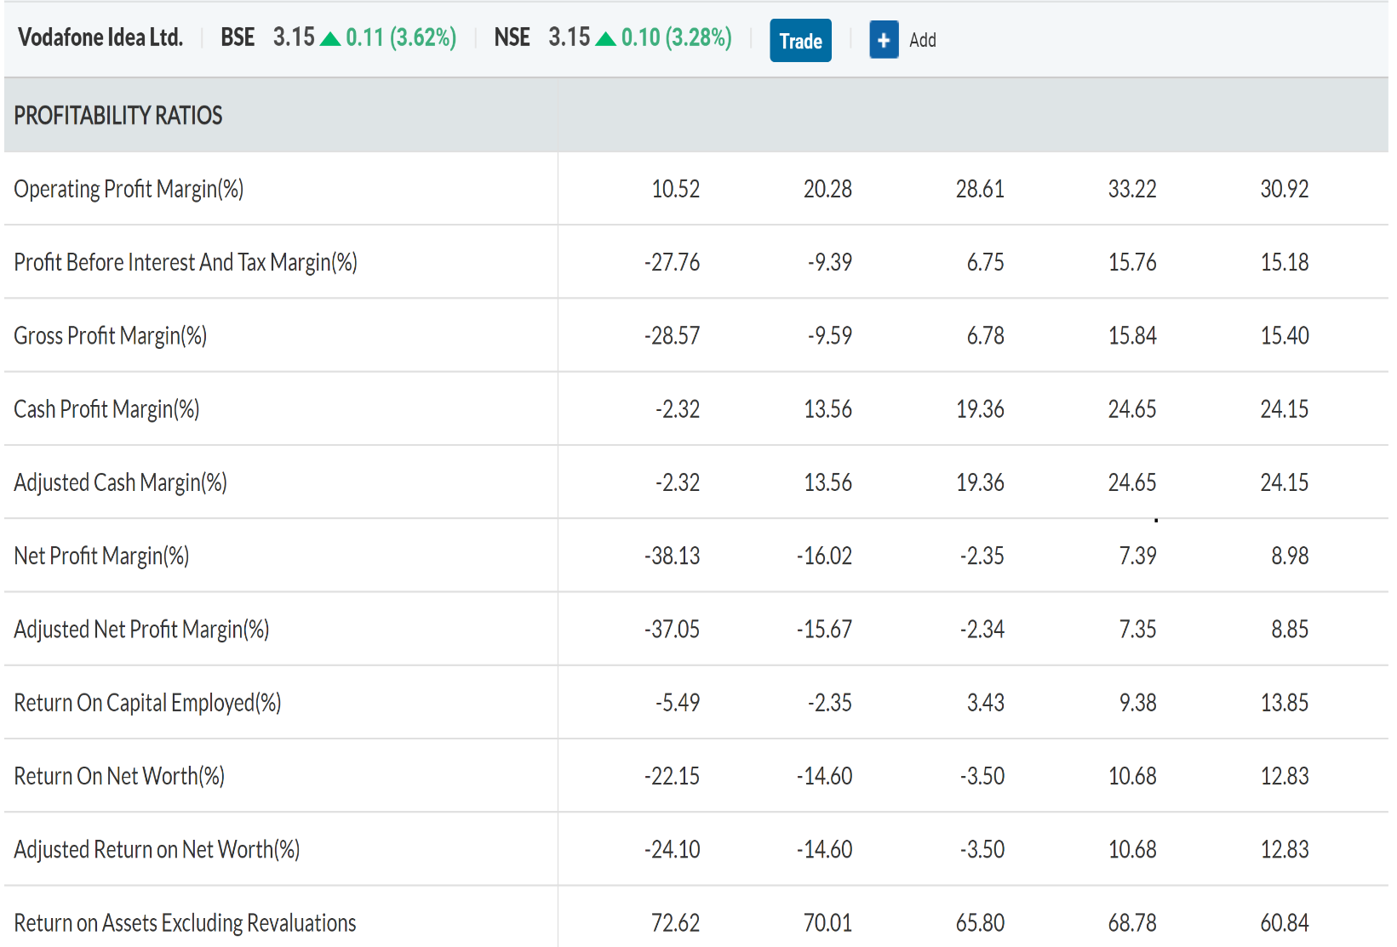**Citation**: Moneycontrol.com. "Vodafone Idea Limited Key Financial Ratios, Vodafone Idea Limited Financial Statement & Accounts." *Vodafone Idea Limited Key Financial Ratios, Vodafone Idea Limited Financial Statement & Accounts*. Moneycontrol, n.d. Web. 20 Nov. 2019. <https://www.moneycontrol.com/financials/vodafoneidealimited/ratios/ic8>.

**SUPPORTING DOCUMENT 2 –** News article on how Vodafone-Idea affects its consumers

**Citation**: D'Cruze, Danny. "How Vodafone, Idea Merger Will Affect Its Consumers." Business Today. N.p., 31 Aug. 2018. Web. 10 Feb. 2020. <https://www.businesstoday.in/sectors/telecom/how-vodafone-idea-merger-will-affect-its-consumers/story/281839.html>.

# How Vodafone, Idea merger will affect its consumers

Vodafone India and Idea Cellular are now Vodafone Idea Limited. With the new company taking the top spot in the Indian telecom industry and dethroning Bharti Airtel for the first time in 15 years, the benefits are expected to seep down to the customers as well. For now, both companies will continue with their individual brands on the public front. For tasks like mobile phone recharge and payment of phone bills, the customer won't witness a major change. Vodafone and Idea websites are still functioning on their old domain. However, the merged capital and increased reach may result in more benefits to users than before.

Welcoming customers to India's leading telecom network, Mr. Balesh Sharma, CEO, Vodafone Idea Limited, said, "As India's leading telecom operator with two popular and loved brands, the company has the scale and resources to ensure sustainable customer choice and introduce new technologies. We are committed to offer both our retail and enterprise customers an excellent experience while fulfilling their evolving digital and connectivity needs via new products, services and solutions. We will offer them more network coverage, more value and more excitement. My team and I look forward to your continuing support and invite you to enjoy the Vodafone Idea experience."

**Better network**

One of the greatest strengths of the merged entity will be a more robust ecosystem of cellular towers. This could yield better coverage than before. The company claims that it is now the largest voice network with over 200,000 unique GSM sites and has 235,000 kms of fibre to cover over 1.2 billion Indians (92% population). Other than that, the new entity will have a large spectrum portfolio and more broadband carriers to provide better service on 2G, 3G and 4G platforms. In the upcoming broadband tariff war, Vodafone Idea will be ready with their consolidated network of over 340,000 broadband sites covering 840 million Indians.

**New technology**

The merged entity will have a better hold on digital services which includes Voice, Data, Mobile payments, IoT, advanced enterprise offerings, high speed and secure leased lines, digital wallets, MIMO and cloud services. These services can be accessed via 15,000 stores and 1.7 million retail touchpoints.

**Competitive offers**

The factor that impacts the end user the most is the price. Vodafone Idea Ltd. will now be better positioned to counter Reliance Jio's aggressive pricing. The company will have a Pan India Revenue Market Share (AGR) of 32.2 per cent which not only puts it on top of the list but also leaves some breathing space for it to introduce new offers.

Idea will infuse Rs 67.5 billion with Vodafone's Rs 86 billion. Additionally, the monetisation of standalone towers of both companies will yield a value of Rs 78.5 billion. This provides the company with a strong cash balance of over Rs 193 billion (after deducting the payout amount of Rs 39 billion to the DoT).

**SUPPORTING DOCUMENT 3 –** News article on Vodafone-Idea status on defending its market share

**Citation**: Parbat, Kalyan. "Vodafone-Idea May Find It Tough to Protect Market Share: Analysts." The Economic Times. Economic Times, 01 Aug. 2018. Web. 20 Nov. 2019. <https://economictimes.indiatimes.com/industry/telecom/telecom-news/vodafone-idea-may-find-it-tough-to-protect-market-share-analysts/articleshow/65222954.cms?from=mdr>.

**Vodafone-Idea may find it tough to protect market share: Analysts**

The emerging Vodafone-Idea merged entity is likely to face a tough time defending its market share and holding on to its high-ARPU data customers as it may be unable to make comparable capex infusions in augmenting 4G network capacity for fighting Bharti AirtelNSE 0.62 % and Reliance Jio Infocomm due to its high leverage and sizeable combined debt levels, analysts said.  
  
Leverage results from using borrowed money, and a highly leveraged company is one with more debt than equity.  
“The Vodafone-Idea merged company will find itself constrained to invest in the business on account of high leverage,” Credit Suisse said in a note seen by ET.  
  
Brokerage JM Financial, in turn, expects the Vodafone-Idea combined entity to “start on a weaker-than-expected wicket with a net debt estimated at Rs 1,150 billion (Rs 1.15-lakh crore) on Day 1”, especially with Idea CellularNSE 3.28 %’s financials “continuing to deteriorate sharply” ahead of its merger with Vodafone India that is nearing completion.  
  
Kumar Birla-led Idea on Monday reported a Rs 263.6 crore net profit in the June quarter, largely on the strength of a one-time exceptional gain from sale of its captive towers business to American Tower Corp.  
  
Without the tower arm sale proceeds, the No 3 telco would have suffered a huge net loss, given the significant deterioration in its operating performance, reflected in the 34.5% sequential fall in earnings before interest, tax, depreciation & amortization (Ebitda) to Rs 659.5 crore in the April-June quarter, analysts said.

Shares of Idea fell over 6% to close at Rs 54.90 on the BSE on Tuesday, a day after the telco reported a weak operational performance in the quarter ended June.  
  
Bank of America-Merrill Lynch said “the merged entity would be vulnerable to market share losses as both Jio and Bharti are ahead of Vodafone and Idea in data investment, and are likely to poach their customers”.  
  
Brokerage JP Morgan said “both Idea and Vodafone India have demonstrated the archetypal conservative behaviour of two debt-stressed firms ahead of a significant merger”.  
  
Analysts estimate the merged entity’s immediate incremental funding needs at Rs 10,000 crore besides debt repayment commitments.  
  
“Though funded for a peak competitive intensity, the merged company’s gearing, estimated at 6.6 times Ebitda even by FY21, will still be out of hand and leaves little headroom for any further operating income (read: Ebitda) decline,” CLSA said in a note.  
  
Jefferies said the capex levels of the Vodafone-Idea merged entity would have to increase substantially to match the (network) capacity generation of peers (read: Airtel and Jio).  
  
Idea’s modest capex at Rs 980 crore in the April-June period is way below Airtel’s Rs 8,200 crore and Jio’s Rs 17,000 crore capex spends in the just-ended quarter.  
  
“With Idea and Vodafone losing postpaid subscribers, we expect blended ARPU to see a sharper fall,” the foreign brokerage said.

Credit Suisse said a particularly worrisome trend before the merger closure is Idea’s stagnant 3G/4G subscriber base, with the telecom arm of the Aditya Birla Group reporting a paltry 1.1 million net increase on-quarter, which is way below “a monthly run-rate of 3 million (adds) for Bharti Airtel and 9 million for Jio”.  
  
In the immediate term, J P Morgan said “it is essential for Idea to get its fair share of subscribers to upgrade to 4G to improve headline ARPUs if overall industry pricing does not improve.

**SUPPORTING DOCUMENT 4 –** News article on technologies used by VIL to defend its market share

**Citation**: Parbat, Kalyan. "Vodafone Idea to Use High-end Tech to Expand 4G Coverage, Defend Market Share." The Economic Times. Economic Times, 22 Nov. 2018. Web. 21 Dec. 2019. <https://economictimes.indiatimes.com/industry/telecom/telecom-news/vodafone-idea-to-use-high-end-tech-to-expand-4g-coverage-defend-market-share/articleshow/66752223.cms>.

**Vodafone Idea to use high-end tech to expand 4G coverage, defend market share**

KOLKATA: Vodafone IdeaNSE 3.28 % will use a combo of advanced technologies such as dynamic spectrum refarming (DSR) to massive MIMO to achieve rapid expansion in its countrywide 4G coverage and data capacity to defend market share in its fight against Reliance Jio Infocomm and Bharti AirtelNSE 0.62 %, analysts present at the telecom market leader’s Wednesday analyst meet said.  
  
Vodafone Idea, born out of the recent merger of Vodafone India and Idea Cellular, expects the blend of these new technologies to expand the company’s 4G population (pop) coverage to 80% by March 2020 from 50% now, and boost data capacity by three times current levels.  
  
The DSR exercise, aimed to efficiently manage deployment of 2G spectrum for 4G LTE services, will be undertaken across 100% of the telco’s sites powered by airwaves in 900 MHz and 1800 MHz bands.

In addition, 3G airwaves in the 2100 Mhz band will start to be de-commissioned in the next 6-to-9 months, brokerage Bank of America Merrill Lynch said, quoting Vodafone Idea’s CTO Nishant Vora, who was present at the analyst meet.  
  
The DSR exercise, Vora said, has already been deployed in Delhi, Kerala and Tamil Nadu, which has led to “significant gains in capacity and indoor experience”.  
  
Analysts though are skeptical about Vodafone Idea’s optimism that its focus on 4G network expansion, simpler tariff structures and recently launched minimum recharge plans will drive ARPU (average revenue per user) recovery.

“VIL’s management expects imminent ARPU recovery, but we suspect that a lot of confidence on cashflows and capital requirement hinges on market repair; an optimism we do not share currently,” Credit Suisse said.  
  
The Swiss brokerage said VIL’s decision to move to just five nationwide prepaid plans could theoretically help ARPU, but “revenue growth could still stay elusive in the current market flux”.

Vodafone Idea’s CEO Balesh Sharma though said at the analyst meet that “price will repair materially in the markets as all telcos are cash negative, demand is high and the number of telcos is down to three”.  
  
Experts like Nitin Soni, director (corporates) at global rating agency, Fitch also believe the turmoil in the industry has largely eased with pricing largely stable for the past three quarters.

With the telecom industry having consolidated down to three dominant players – Vodafone Idea, Bharti Airtel and Reliance Jio – some experts believe the situation is ideal for pricing power to return over time.  
  
VIL indicated at the analyst meet it plans to run both the “Vodafone” and “Idea” brands on grounds of their unique strengths and has no immediate plans to merge them. The company also plans to sharply reduce distributor base, retail footprint and call centre capacity to less than 50% of pre-merger, combined levels.  
  
Vodafone Idea, which recently posted a loss of Rs 4,974 crore for the quarter ended September 2018, though is saddled with sizeable spectrum liabilities, of which Rs 3,000 crore is due in March 2019 and an additional Rs 12,000 crore would be due in mid-FY20.  
  
Brokerage UBS said VIL’s Rs 27,000 crore capex guidance for FY19/20 combined together still falls short of capex projections of peers Airtel and Jio).

**SUPPORTING DOCUMENT 5 –** Interview with regional manager of Vodafone idea

**(Q1) ME**: What do you think about the brand recognition of VIL in the market?

**MANAGER**: VIL is a merger of the telecom companies, Vodafone and Idea. These companies are very much known in the market. Since these companies already carry brand image, VIL is a well-recognized brand. Vodafone and Idea have merged to create a stronger brand in the market. Both the brands are synchronizing their entire business.

**(Q2) ME**: In your opinion, how much is the brand loyalty of customers for VIL compared to other telecom companies in the market?

**MANAGER**: Most of the customers that have been subscribed Vodafone or Idea are subscribed to VIL. Having the brand image developed already in the market, VIL is not facing much issues in terms of its customer base. They have a large customer base, with a robust network infrastructure.

**(Q3) ME**: What strategies is the company initiating to establish itself as a strong player in the market after the merger?

**MANAGER**: The company is aiming to advance technology by using high-end tech to expand 4G coverage. Also, for this, they are aiming to keep their costs/expenses low and increase their profit margin.

**(Q4) ME**: What has been the financial state of the company after the company?

**MANAGER**: The company is facing financial issues trying to provide its best services to its large customer base. Because of their investments in towers to expand their coverage and provide customers with a fast data speed, the expenses are increasing which is resulting in a lower gross and net profit margin for the company. Due to the VIL’s financial issues, there might be a time when the company would be making a lot of loss and would need to shut down its services which would result in their loss of customer base and loss of profits into the business. Therefore, to prevent this from happening, the company is trying to cut its costs down and finding an efficient and effective way to manage its services.

**(Q5) ME**: What opinions do you have about the merging of Vodafone and Idea as a whole? Do you think this benefited the companies?

**MANAGER**: I think it has benefited as a whole. For Vodafone and Idea to prevent themselves from losing their position in the market, they have merged to create a larger network. VIL is a bargain brand that will be providing more service and costing less. Merging have brought the companies back in the market as strong competitors. VIL now competes the top telecom companies, Bharti Airtel and Jio, aiming to place 1st in the market.

1. Refer to Q1 of the interview in the supporting document 5.
2. "Merger of Idea and Vodafone India Completed." *Idea Cellular – Cell Phone Services |3G, Prepaid, Postpaid & Wireless Internet*. N.p., 31 Aug. 2018. Web. 10 Nov. 2019. <https://www.ideacellular.com/media-centre/news/national-news/merger-of-idea-and-vodafone-india-completed>.
3. Supporting Document 3 - News article on Vodafone-Idea status on defending its market share.
4. VIL Quarterly Report, 2018. Gujarat: Vodafone Idea Limited (Formerly Idea Cellular Limited)), 2018. VIL QR_Q3FY19. 31 Dec. 2018. Web. 15 Nov. 2019. <https://www.vodafoneidea.com/content/dam/vodafone-microsite/docs/pdf/VIL%20QR_Q3FY19.pdf>
5. Refer to Q2 of the interview in the supporting document 5.
6. Rajawat, Yatish. "Telecom Quality Issues: Facing Network Issue with Vodafone, Airtel, Idea, &amp; Reliance Jio?" LocalCircles. N.p., 4 June 2018. Web. 11 Dec. 2019. <https://www.localcircles.com/a/press/page/telecom-quality-issue-facing-network-issue-with-vodafone-airtel-idea-reliance-jio#.Xe9aNOgzZnI>.
7. Maity, Amit. "Perceptual Mapping." LinkedIn SlideShare. N.p., 13 July 2018. Web. 5 Dec. 2019. <https://www.slideshare.net/amitmaity12/perceptual-mapping-105709260>.
8. Refer to the Q5 of the interview in the supporting document 5.
9. VIL Quarterly Report, 2018. Gujarat: Vodafone Idea Limited (Formerly Idea Cellular Limited)), 2018. VIL QR_Q3FY19. 31 Dec. 2018. Web. 15 Nov. 2019. <https://www.vodafoneidea.com/content/dam/vodafone-microsite/docs/pdf/VIL%20QR_Q3FY19.pdf>
10. Ibid
11. Supporting Document 2 - News article on how Vodafone-Idea affects its consumers.
12. Supporting Document 1 – Financial ratios of VIL.
13. Supporting Document 3 - News article on Vodafone-Idea status on defending its market share.
14. Refer to Q4 of the interview in the supporting document.
15. Supporting Document 4 - News article on technologies used by VIL to defend its market share.
16. Refer to Q3 of the interview in the supporting document 5.